Code Assignment

**(U5A2)**

**ANN Deployment**

**MNIST Dataset**

**Submitted To: Dr. Rahul Krishnan**

**Sumitted By : Shashwat Srivastava**

**15 marks**

Use the MNIST handwritten digit classification dataset.

**WRITE YOUR ANSWERS BRIEFLY, and ONLY IN THE RELEVANT SPACE GIVEN FOR THE ANSWER.**

1. You have already trained a model in your previous ANN MNIST exercise given in the class. Save and download that model.  
   Create your google colab notebook and load the already trained model.  
     
   The goal of this assignment is to load the trained MNIST ANN model and make it predict the a custom input (a digit written by you on a paper)
2. Write two digits (the last two digits of your roll number) separately on two pieces of paper and put the photos below.

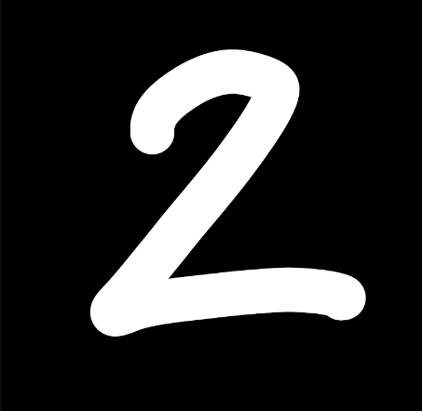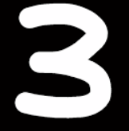

1. Do preprocessing of the image so that it matches with the input type on which the ML model was trained on. Put down the images of the 2 digits after preprocessing it.

**Approach**

The basic approach to preprocess it was to read the file and convert it to greyscale first. Then the image had to converted to an image array and had to be resized into the shape of 28x28 pixels. The size of the images in MNIST database is the same i.e. 28x28 pixels. After that, the image had to be scaled by dividing with 255 so that all the pixel values can be normalized down to a value between 0-1. We flatten the image_array and take a transpose. After which we put into another array because the dataset is an array of arrays, so we had to convert it into the same format for the model to work. We use the values of Theta1 and Theta2 to predict the values of the images preprocessed.

**Code to Preprocess the Image**

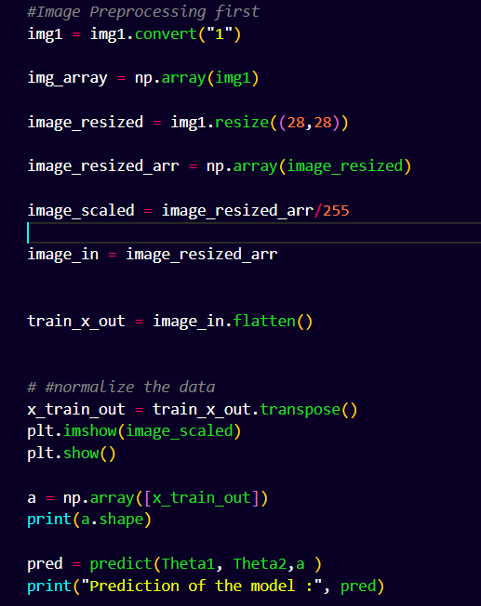

**Preprocessed Images**

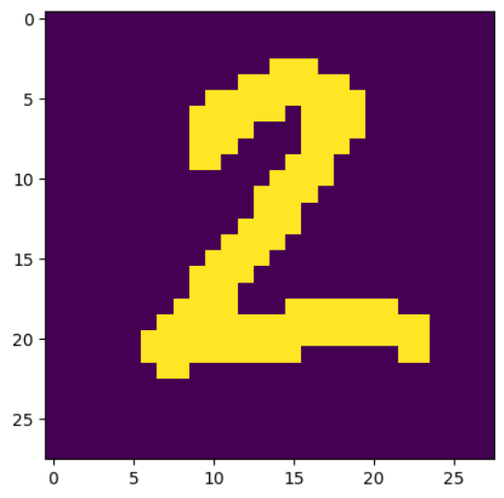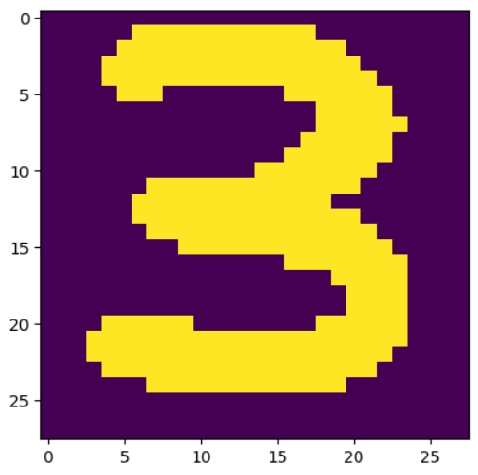

1. **[5 Marks]** Use the pre-trained model to predict the digits and print the predictions along with the actual (preprocessed) image. Put down the screenshot of the output.

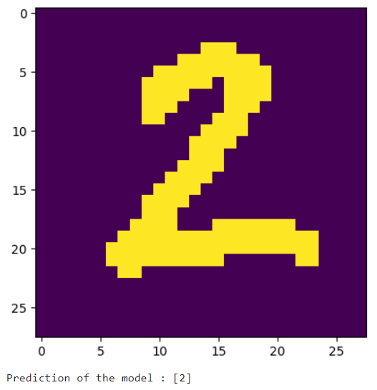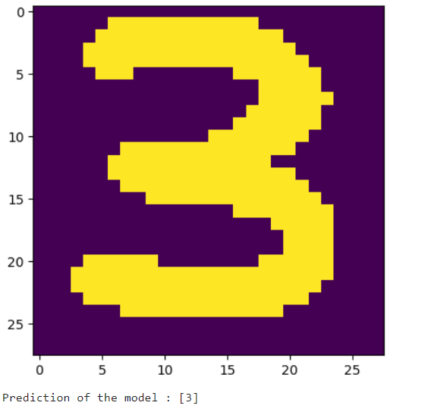

1. **[4 Marks] Upload the .py code along with this document.**

[**https://github.com/shashwatsrii/Machine_Learning/blob/main/Neural%20Networks/Hand%20Written%20Text%20Recognition/HDR_ANN.ipynb**](https://github.com/shashwatsrii/Machine_Learning/blob/main/Neural%20Networks/Hand%20Written%20Text%20Recognition/HDR_ANN.ipynb)

**Submit the above in the Teams portal.**

**Grading scheme (Total 15 Marks)**

**Time - 4 hours max.**

**Submission on Teams by 11.30 PM, 18 May 2023.**

**Working Professional submission : 11.30 PM, 21 May 2023.**Late submissions are allowed, although it will result in a reduction of 20% marks.

**Plagiarism Policy**

You are **NOT** allowed to discuss. You cannot copy paste text/image from the internet or other sources. All assignments are put through TurnitIn, and any similarity score of more than 40% will be flagged as plagiarism. The penalties are as follows.

* 1st instance of plagiarism - **0 marks for this assignment**
* 2nd instance of plagiarism - **GRADE DOWN for the entire course**
* 3rd instance of plagiarism - **FAIL in the course**

*For group submissions, the above policy will be enforced on all the team members equally.*

By submitting this assignment, you/your group agree to the above policies on grading, submission and plagiarism, and the person submitting on behalf of the group is assumed to have taken consent from their group members.